



Weekly Status Report
Aptech Limited
Submitted By
Operisoft Technologies Pvt Ltd
23/09/2026



Cost Summary Difference of All AWS Accounts

No | Account Name | Account ID | Last Week Cost (31st Aug to 6th Sep) | Tax  Cost | Current Week Cost (7th Sep to 13th Sep) | Services
1 | Aptrack 1.0 - DC  [Aptech] | 654654548701 | $343.81 | $64.89 | $340.00 | The costs slightly decreased due to the following services: EC2-Instances, EC2-Other.
2 | Aptrack 2.0 - NonProd UAT  [MEL] | 767397805488 | $1,064.03 |  | $993.49 | The costs decreased due to the following services: EC2-Instances, EC2-Other.
  $188.92
3 | Aptrack 2.0 OldManagement A/c  [MEL]/Production | 15747350560 | $2,047.39 | $824.04 | $2,049.19 | The costs slightly increased due to the following services: EC2-Instances.
4 | Aptrack 1.0 - DR  [Aptrack5.0] | 590183710228 | $127.73 | $21.36 | $120.80 | The costs decreased due to the following services: EC2-Other.
5 | Aptrack -ProAlle | 617172754330 | $235.33 | $73.89 | $183.25 | The costs decreased due to the following services: OpenSearch Service.
6 | Aptrack - 2.0 - Shared Service  [MEL] | 533267037955 | $329.61 | $46.81 | $290.24 | The costs have decreased due to following services: EC2-Other, Network Firewall.
7 | Aptrack-SAP-Dev  and Quality | 528757792293 | $102.75 | $17.66 | $103.29 | The cost remains same.
8 | Aptrack-SAP-  Production | 195275643918 | $153.40 | $45.05 | $153.85 | The cost remains same.
9 | Aptrack – LCMS | 771423618181 | $113.24 | $25.37 | $113.24 | The costs decreased compared to previous week due to usage of CloudFront.
10 | Aptech-  ProConnect | 108782065415 | $246.55 | $48.59 | $188.14 | The costs have decreased compared to previous week due to the usage of the following services: Relational Database Service.
11 | Aptrack - QnA Snipping Tool  Solution | 211125374996 | $53.67 | 10.57 | $90.01 | The costs increased compared to previous week due to usage of following services: EC2-instances.
12 | Aptech-LAPA | 343218180162 | $22.71 | $3.77 | $29.27 | The costs increased compared to the previous week due to the following services, such as CloudFront and WAF.
13 | Aptrack- Arena  034362049944 | 34362049944 | $87.55 | $3.66 | $46.97 | The costs have decreased compared to the previous week due to the  usage of services such as CloudFront.
14 | Aptech Avalon | 985539791413 | $4.99 | $0.74 | $4.85 | The cost remains same.
15 | Aptech  AI_Applications | 166185345052 | $16.98 | $3.02 | $18.74 | The cost slightly increased compared to the previous week due to usage of services: Bedrock.
16 | Aptrack  AR_VR_MAAC | 377555974222 | $41.64 | $7.55 | $41.64 | The cost remains same.
17 | Aptrack - 2.0 - Log  archive [MEL] | 637423329781 | $2.68 | $0.48 | $2.68 | The cost remains same.
18 | Aptech-Domains | 622050225451 | $15.07 | $2.42 | $1.84 | The costs have decreased compared to the previous week due to the usage of services such as Route53.
19 | Aptrack - 2.0 -  Audit [MEL] | 851725245759 | $0.36 | $0.05 | $0.37 | The cost remains same
20 | Aptech International | 470684059456 | $17.96 | $2.99 | $17.89 | The cost remains same
Total Cost |  |  | ⬆️$5,027.45 | $1,391.84 | ⬇️$4,789.75
- The billing for the current week (7th September to 13th September) has decreased compared to the previous week.
- The cost difference is $237.70.

security best practices: -

Content | Link
Best Practices for AWS root users | https://docs.aws.amazon.com/accounts/latest/reference/best-practices-root-user.html
Best Practices for AWS  Access Keys | https://docs.aws.amazon.com/accounts/latest/reference/credentials-access-keys-best-practices.html
Shared Responsibility Model | https://aws.amazon.com/compliance/shared-responsibility-model/
AWS Cloudtrail | https://aws.amazon.com/cloudtrail/
Trusted Advisor | https://aws.amazon.com/premiumsupport/trustedadvisor/
Creating Billing alarms | https://docs.aws.amazon.com/AmazonCloudWatch/latest/monitoring/gs_monitor_estimated_charges_ with_cloudwatch.html#gs_creating_billing_alarm
Enable MFA | https://docs.aws.amazon.com/IAM/latest/UserGuide/id_credentials_mfa.html
GIT Secrets | https://github.com/awslabs/git-secrets

---------------------------------------------------------------------------------------------------------- Summary ----------

Aptrack 1.0 - DC [Aptech] – 654654548701
-------------------------------------------------------------------------------------------------------------------------------

Billing and Cost Overview

  - Total cost for the week: $340.00
  - Average Daily Cost: $48.57

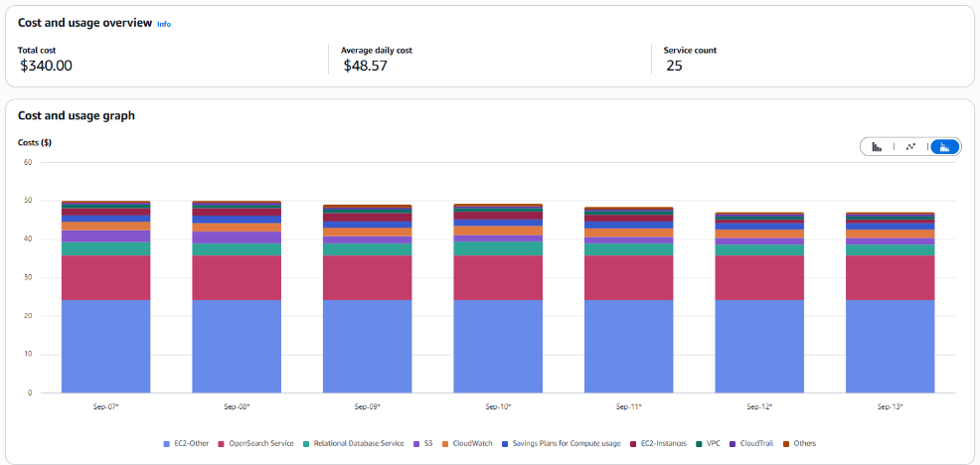
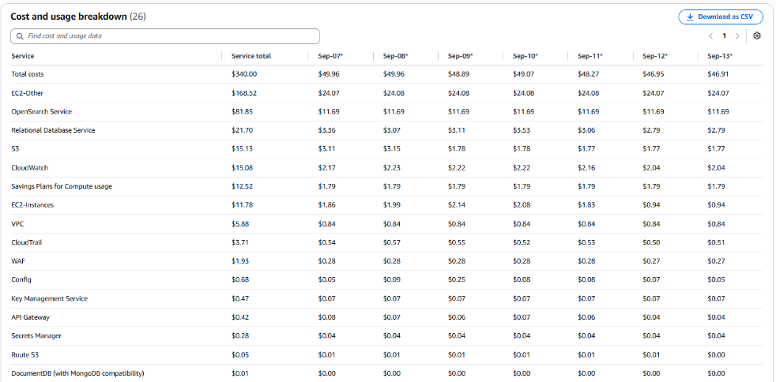

- The costs slightly decreased due to the following services: EC2-Other(APS3-EBS:SnapshotUsage), EC2-Instances(, APS3-BoxUsage:c6a.xlarge)

No Activity performed by Operisoft in this account.

- Resource Utilization & Alarms

All EC2 Server Alarms triggered between (14 September 2026 to 20 September 2026)
Server Name | Region | Memory/Disk/CPU | Alert date and no. of trigger
PIPELINE_SERVER  (i-051ecadd578639f19) | ap-south-1 | Disk 95% [/] | September 15(1 Time)
PIPELINE_SERVER  (i-051ecadd578639f19) | ap-south-1 | Disk 90% [/] | September 15(3 Times)  September 17(3 Times)

--------------------------------------------------------------------------------------------Summary--------

Aptrack 2.0 - NonProd UAT [MEL]- 767397805488
--------------------------------------------------------------------------------------------------------------

Billing and Cost Overview

- Total cost for the week: $993.49
- Average Daily Cost: $141.93

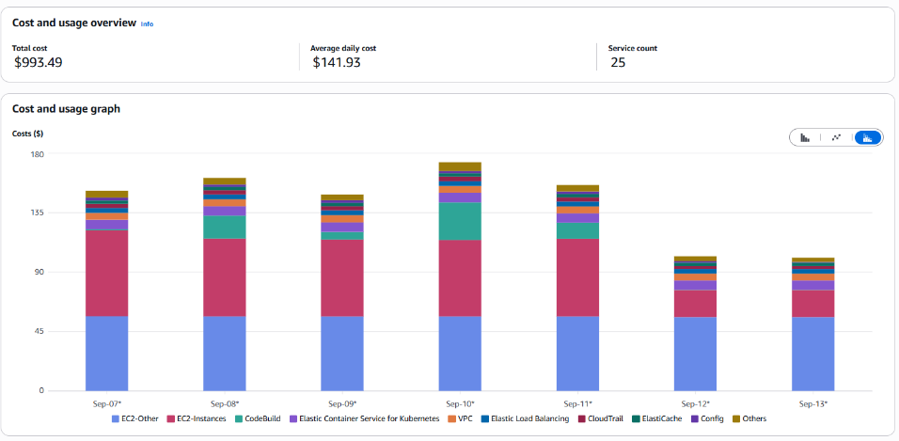

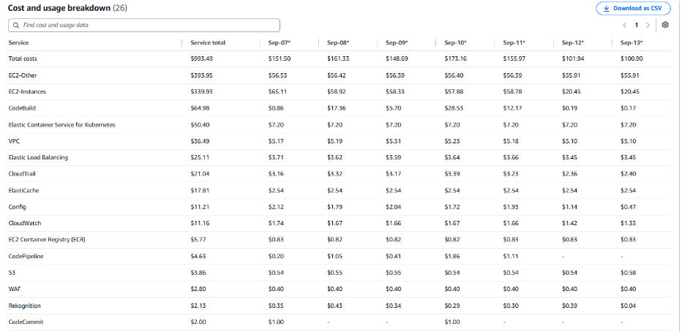

- The costs decreased due to the following services: EC2-Other(APS3-EBS:VolumeUsage.gp3), EC2-Instances (APS3-BoxUsage:r6a.2xlarge, APS3-BoxUsage:t4g.xlarge)

- No Activities performed by Operisoft in this account.

Resource utilization & alarms.

All EC2 Server Alarms triggered between (14 September 2026 to 20 September 2026)
Server Name | Region | Memory/Disk/CPU | Alert date and no. of trigger
aptrack-np-reporting-db+snapshot-db  (i-02f5198e95bff8b1f) | ap-south-1 | Disk 80% [C:] | September 14(1 Time)  September 15(1 Time)  September 16(1 Time)  September 18(2 Times)  September 19(7 Times)  September 20(1 Time)
Aptrack-pk-uat-master-(formally-pre-prod)  (i-0fa449af963f6300e) | ap-south-1 | CPU 90% | September 15(7 Times)  September 16(8 Times)  September 17(9 Times)  September 18(1 Time)
 | ap-south-1 | CPU 80% | September 14(11 Times)  September 15(2 Times)  September 16(1 Time)  September 17(1 Time)  September 18(1 Time)
Aptrack-UAT-Master-DB-(UAT-SERVER)  (i-0549f07f123ead151) | ap-south-1 | Disk 90% [F:] | September 14(1 Time)  September 15(1 Time)  September 16(2 Times)  September 17(1 Time)  September 18(1 Time)
Aptrack-UAT-Reporting-DB-(UAT-SERVER)  (i-067e46273d66367ad) | ap-south-1 | Disk 90% [C:] | September 14(1 Time)  September 15(1 Time)  September 16(6 Times)  September 17(7 Times)  September 18(1 Time)

--------------------------------------------------------------------------------------------------------------Summary----------

Aptrack 2.0 - Old Management A/c [MEL] - 015747350560
----------------------------------------------------------------------------------------------------------------------------------

Billing and Cost Overview

  - Total cost for the week: $2,049.19
  - Average Daily Cost: $292.74

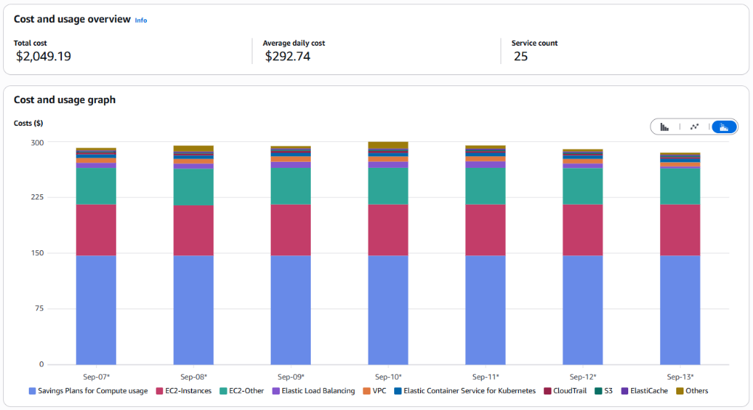

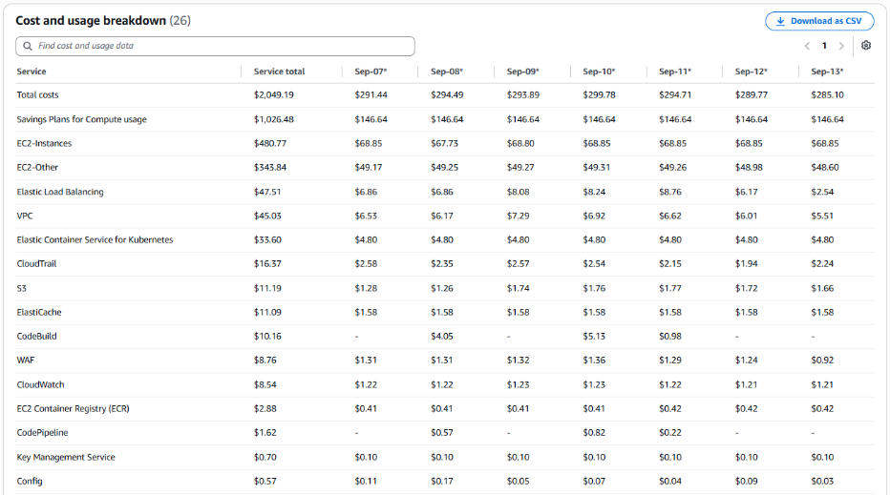

- The costs increased due to the following services: EC2-Instances(APS3-BoxUsage:r6a.4xlarge).
- No Activities performed by Operisoft in this account.

- Resource Utilization & Alarms

All EC2 Server Alarms triggered between (14 September 2026 to 20 September 2026)
Server Name | Region | Memory/Disk/CPU | Alert date and no. of trigger
Monitoring-Server  (i-0c429eb752c2ae3d9) | ap-south-1 | Memory 90% | September 19(1 Time)
Monitoring-Server  (i-0c429eb752c2ae3d9) | ap-south-1 | Memory 80% | September 19(2 Times)  September 20(2 Times)
PROD-Aptrack-Reporting-New  (i-00b4573a7e653e931) | ap-south-1 | Memory 85% | September 14(2 Times)  September 15(14 Times)  September 16(17 Times)  September 17(11 Times)  September 18(5 Times)  September 19(1 Time)  September 20(2 Times)
Prod-PK-Aptech-Master-Database  (i-00982ca7fd10a06b8) | ap-southeast-5 | CPU 80% | September 14(1 Time)  September 17(1 Time)  September 18(1 Time)  September 19(1 Time)
Prod-PK-Aptech-Master-Database  (i-00982ca7fd10a06b8) | ap-southeast-5 | Memory 80% | September 20(1 Time)
Prod-PK-Aptech-Reporting-Database  (i-0ec1be4623b31974c) | ap-southeast-5 | CPU 80% | September 14(1 Time)
Prod-PK-Aptech-Reporting-Database  (i-0ec1be4623b31974c) | ap-southeast-5 | Memory 80% | September 14(4 Times)
Prod-PK-Aptech-Reporting-Database  (i-0ec1be4623b31974c) | ap-southeast-5 | Disk 80% [C:] | September 17(1 Time)
Prod-PK-Aptech-Reporting-Database  (i-0ec1be4623b31974c) | ap-southeast-5 | Disk 90% [C:] | September 17(1 Time)
Prod-PK-Aptech-Reporting-Database  (i-0ec1be4623b31974c) | ap-southeast-5 | Disk 98% [C:] | September 14(1 Time)  September 17(1 Time)

--------------------------------------------------------------------------------------------------------------Summary------

Aptrack 1.0 - DR [Aptrack 5.0] - 590183710228
---------------------------------------------------------------------------------------------------------------------------------

Billing and Cost Overview

  - Total cost for the week: $120.80
  - Average Daily Cost: $17.26

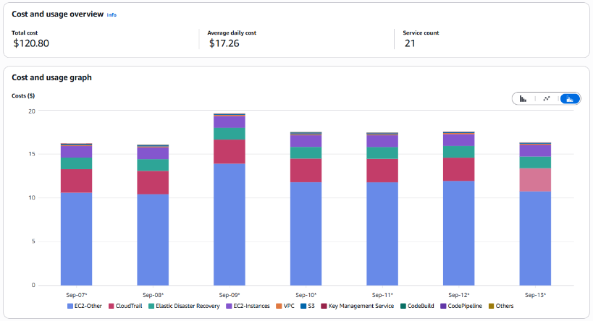

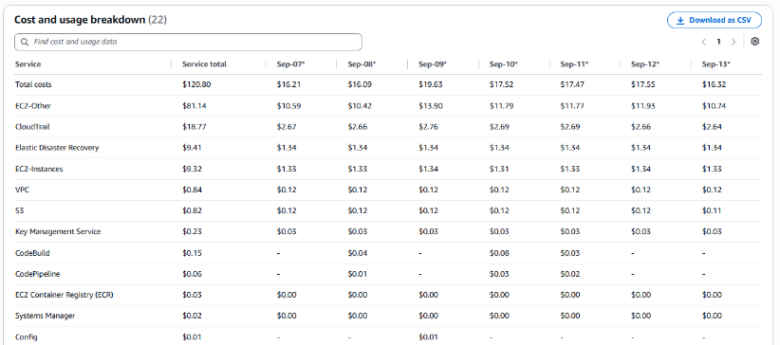

- The costs increased due to the following services: EC2-Other (APS5-EBS:VolumeUsage.gp3 ).
- Resource Utilization & Alarms.
- There are only EDRS Servers.
- No Activities performed by Operisoft in this account.

--------------------------------------------------------------------------------------------------------Summary-------------

Aptrack -ProAlle - 617172754330
-------------------------------------------------------------------------------------------------------------------------------

Billing and Cost Overview

  - Total cost for the week: $183.25
  - Average Daily Cost: $26.18

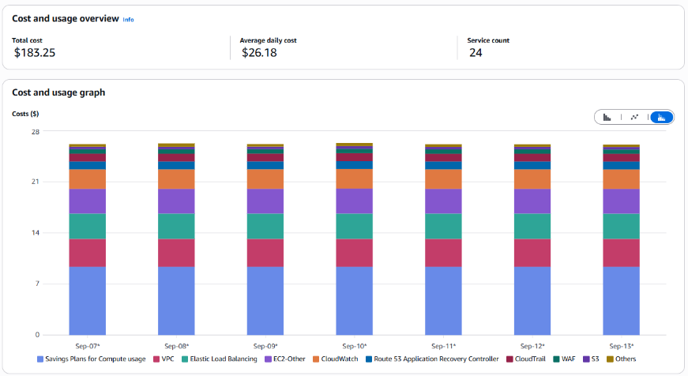

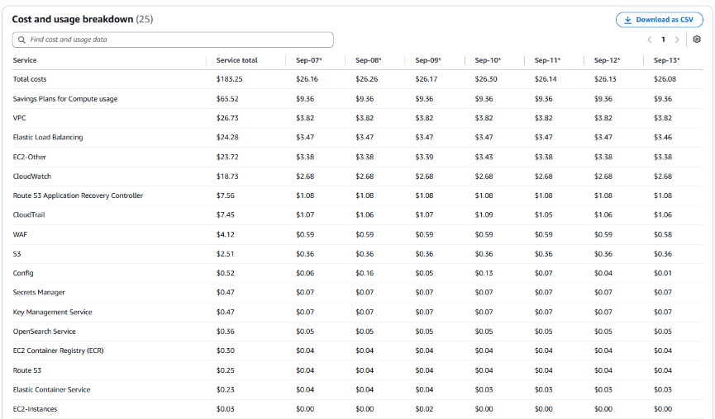

- The costs decreased due to the following services: OpenSearch Service.
- No Activity performed by Operisoft in this account.
- No Resource Utilization & Alarm.

------------------------------------------------------------------------------------------------------------Summary---------

Aptrack - 2.0 - Shared Service [MEL] - 533267037955
-------------------------------------------------------------------------------------------------------------------------------

Billing and Cost Overview

  - Total cost for the week: $290.24
  - Average Daily Cost: $41.46

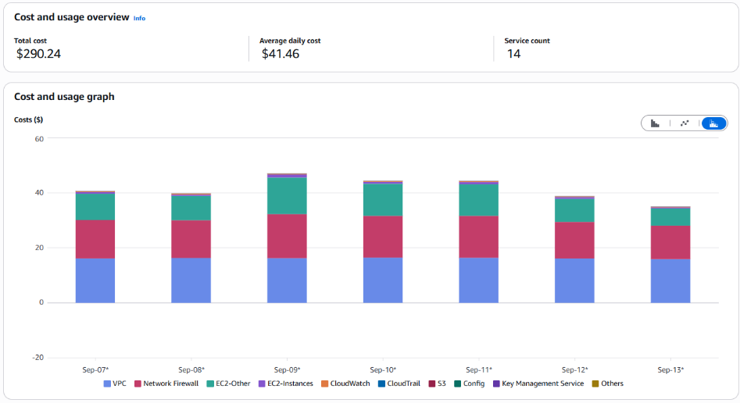
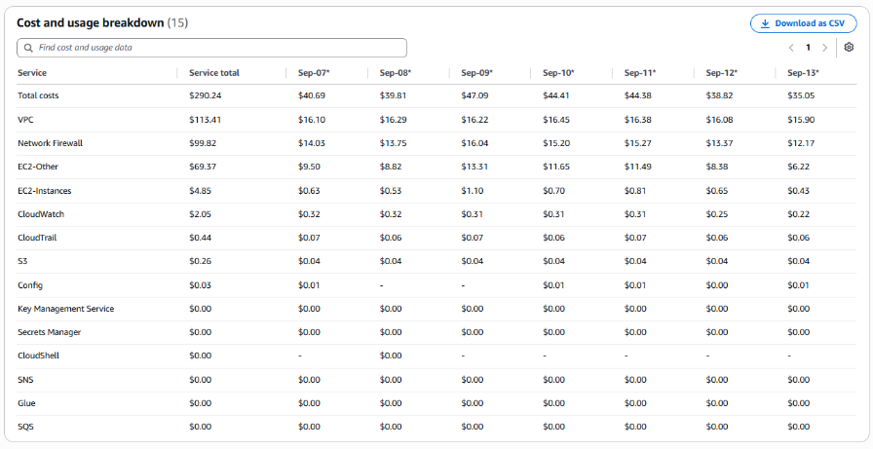

- The costs have decreased due to following services: EC2-Other (APS3-NatGateway-Bytes, APS3-APS5-AWS-Out-Bytes), Network Firewall(APS3-Traffic-GB-Processed)
- No Activity performed by Operisoft in this account.
- No Resource Utilization & Alarms.

---------------------------------------------------------------------------------------------------------Summary----------

Aptrack –SAP-Dev and Quality – 528757792293
------------------------------------------------------------------------------------------------------------------------------

Billing and Cost Overview

  - Total cost for the week: $103.29
  - Average Daily Cost: $14.76

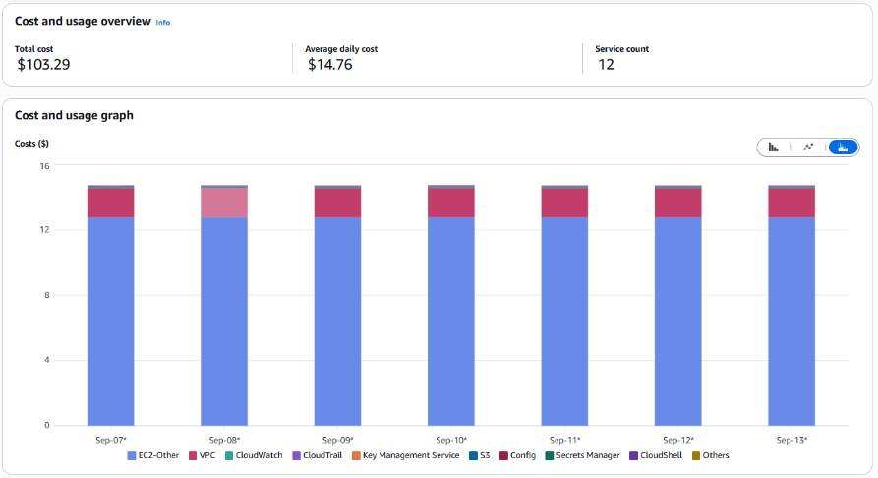

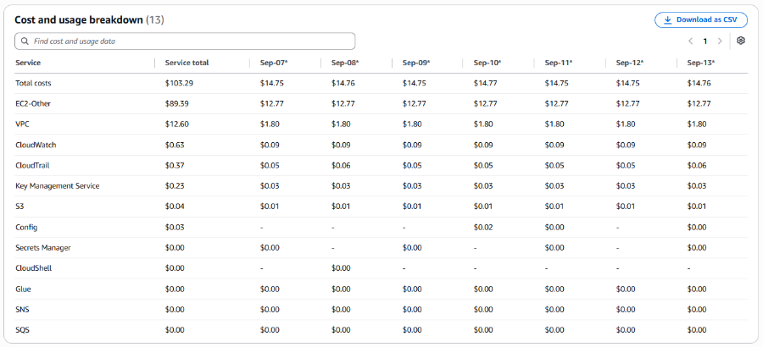

- The cost remains same.
- No Activity performed by Operisoft in this Account.
- No Resource Utilization & Alarms.
----------------------------------------------------------------------------------------------------------Summary---------

Aptrack- SAP- Production - 195275643918
-----------------------------------------------------------------------------------------------------------------------------

Billing and Cost Overview

  - Total cost for the week: $153.85
  - Average Daily Cost: $21.98
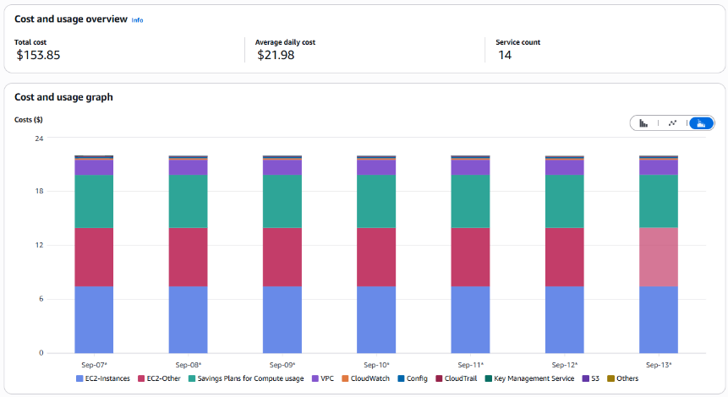
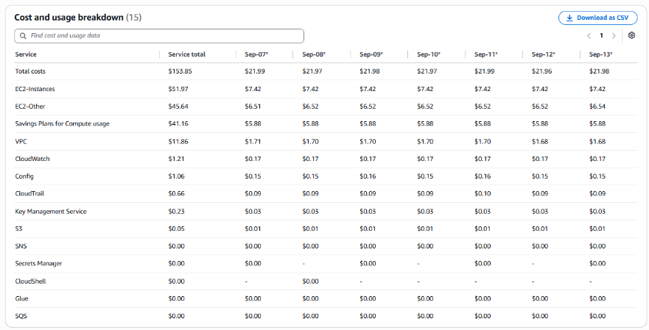
- The cost remains same.
- No Activity performed by Operisoft in this account.
- No Resource Utilization & Alarms.

----------------------------------------------------------------------------------------------------------Summary----------

Aptrack – LCMS - 771423618181
------------------------------------------------------------------------------------------------------------------------------

Billing and Cost Overview

  - Total cost for the week: $138.61
  - Average Daily Cost: $19.80
  - Total Tax Cost: $25.37

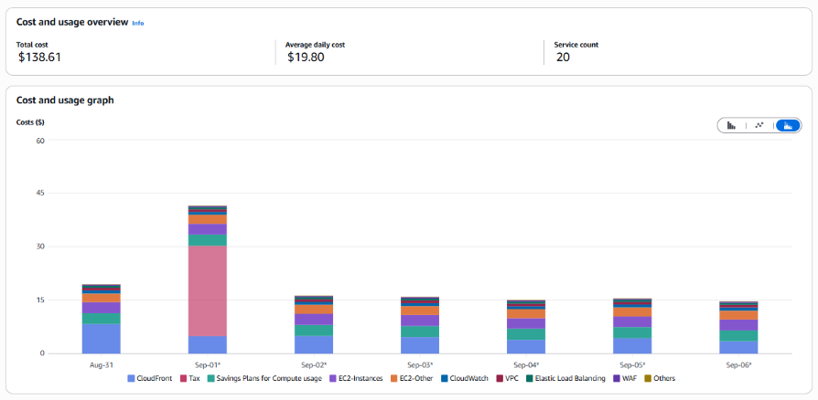
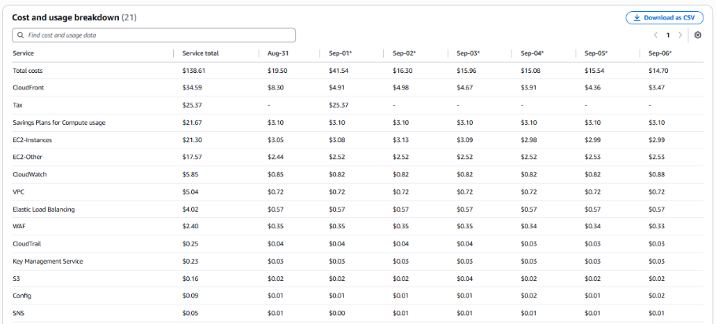
- The costs decreased compared to previous week due to usage of CloudFront (IN-DataTransfer-Out-Bytes, IN-Requests-Tier2-HTTPS) For the Distribution ID (E1Q7B79HP7VHAW, E1ZQZAROZ9TJKC, E3JEVK1GBK07S8) for the domain names (www.maacindia.com, maacindia.com, assets.maacindia.com, maac24fps.com).

- No Activity performed by Operisoft in this account.

- Resource Utilization & Alarms.
All EC2 Server Alarms triggered between (14 September 2026 to 20 September 2026)
Server Name | Region | Memory/Disk/CPU | Alert date and no. of trigger
maacindia-proxy  (i-01fdbbbf24efc3f0b) | ap-south-1 | CPU 90% | September 18(2 Times)
maacindia-proxy  (i-01fdbbbf24efc3f0b) | ap-south-1 | CPU 80% | September 18(2 Times)  September 20(4 Times)
maacindia-proxy  (i-01fdbbbf24efc3f0b) | ap-south-1 | Memory 80% | September 18(1 Time)  September 20(5 Times)

------------------------------------------------------------------------------------------------------Summary-------------

Aptrack – ProConnect - 108782065415
-----------------------------------------------------------------------------------------------------------------------------

Billing and Cost Overview

  - Total cost for the week: $188.14
  - Average Daily Cost: $26.88
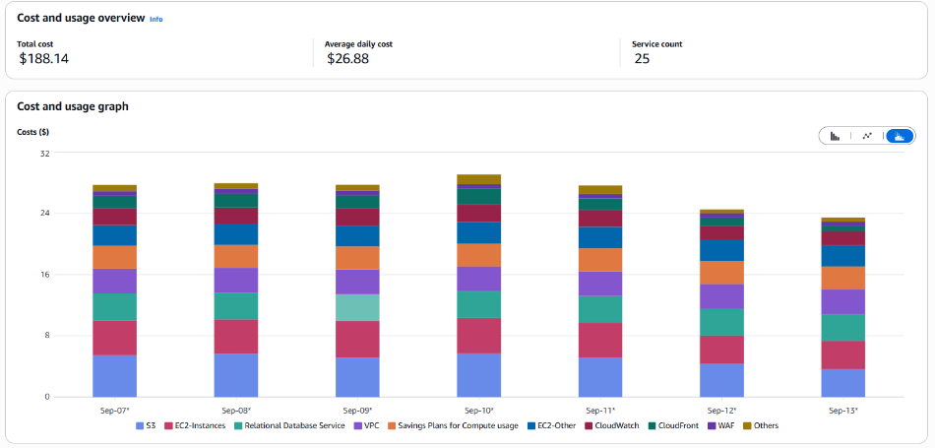
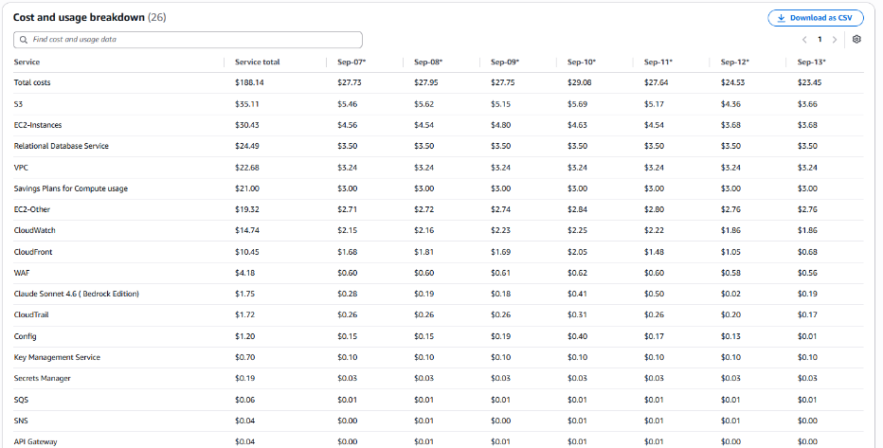

- The costs have decreased compared to previous week due to the usage of the following services: RDS(APS3-HeavyUsage:db.t3.medium)
- No Activity performed by Operisoft in this account.

- Resource Utilization & Alarm.

All EC2 Server Alarms triggered between (14 September 2026 to 20 September 2026)
Server Name | Region | Memory/Disk/CPU | Alert date and no. of trigger
proconnect-chatbot  (i-0ac87a4c06079ee38) | ap-south-1 | Disk 80% [/] | September 16(1 Time)
Prod-Proconnect  (i-0a1e00efe0850c119) | ap-south-1 | Memory 80% | September 16(3 Times)  September 17(17 Times)

-----------------------------------------------------------------------------------------------------Summary------------

Aptrack - QnA Snipping Tool Solution - 211125374996
----------------------------------------------------------------------------------------------------------------------------

Billing and Cost Overview

  - Total cost for the week: $90.01
  - Average Daily Cost: $12.86

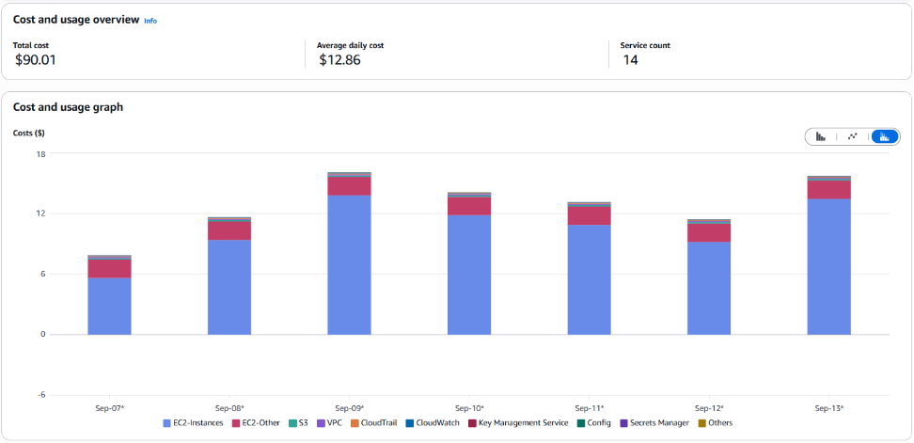

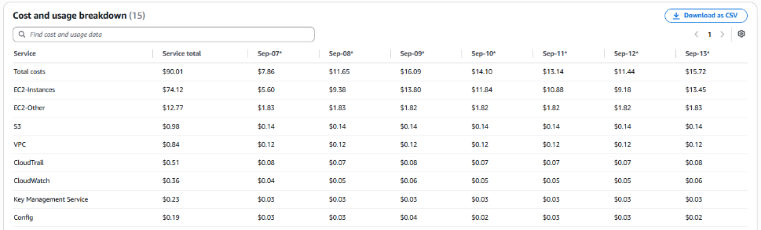

- The costs increased compared to previous week due to usage of following services EC2-instances (APS3-BoxUsage:t3a.xlarge).
- No Activity performed by Operisoft in this account.
- No Resource Utilization & Alarm.

-----------------------------------------------------------------------------------------------------Summary--------------
Aptech- LAPA - 343218180162
------------------------------------------------------------------------------------------------------------------------------

Billing and Cost Overview
  - Total cost for the week: $29.27
  - Average Daily Cost: $4.18
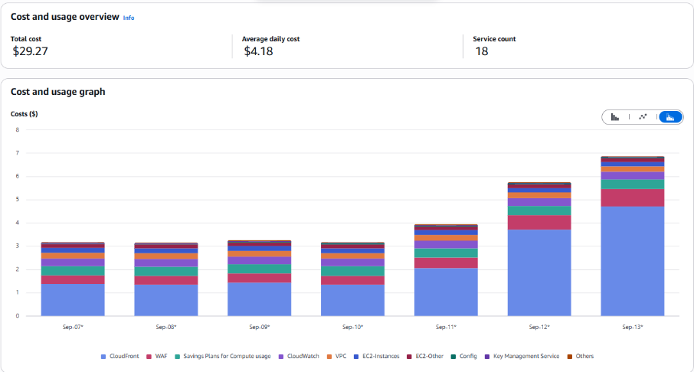

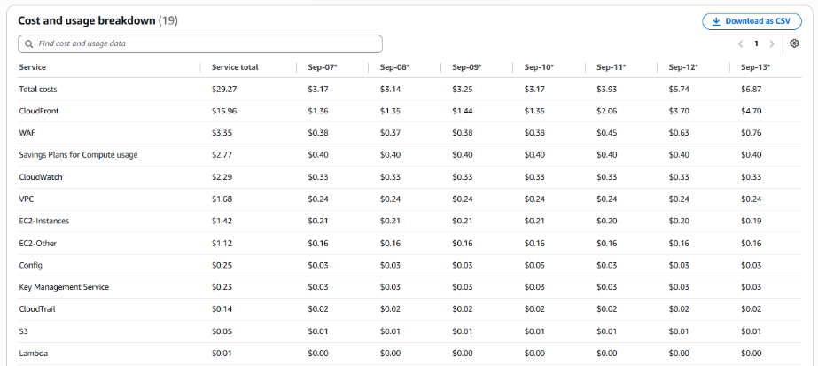

- The costs increased compared to the previous week due to the following services, such as CloudFront (IN-DataTransfer-Out-Bytes, IN-Requests-Tier2-HTTPS) Distribution ID E1KCOXJJUTSNJ9 For the domain www.lakme-academy.com and WAF.
- No Activity performed by Operisoft in this account.
- NO Resource Utilization & Alarms

-------------------------------------------------------------------------------------------------------Summary-------------
Aptrack- Arena – 034362049944
-------------------------------------------------------------------------------------------------------------------------------

Billing and Cost Overview

  - Total cost for the week: $46.97
  - Average Daily Cost: $6.71
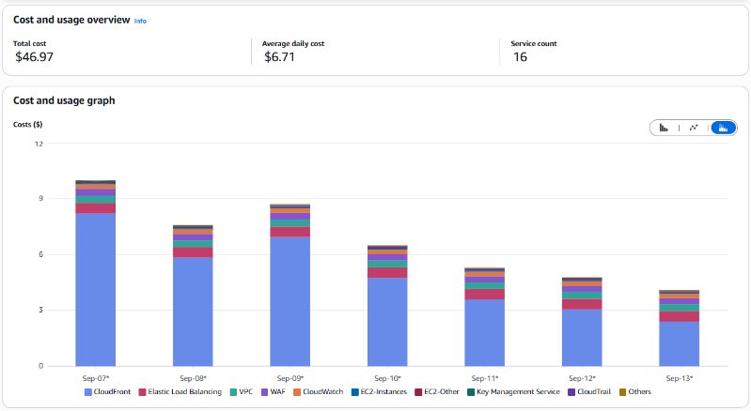
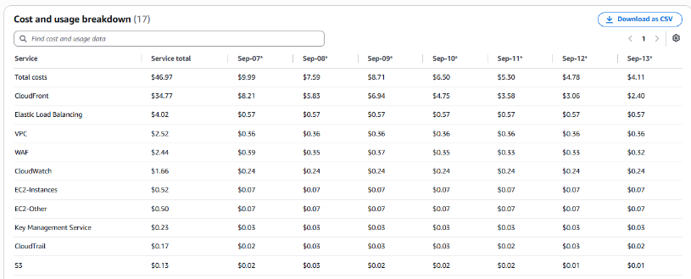
- The costs decreased compared to the previous week due to the usage of services such as CloudFront (IN-DataTransfer-Out-Bytes) for Distribution ID E1KPCBIKSTPNNC with Domain: www.arena-multimedia.com, arena-multimedia.com.

- No Activity performed by Operisoft in this account.
- No Resource Utilization & Alarm.

---------------------------------------------------------------------------------------------------------Summary-----------
Aptech Avalon-985539791413
------------------------------------------------------------------------------------------------------------------------------

Billing and Cost Overview

  - Total cost for the week: $4.85
  - Average Daily Cost: $0.69
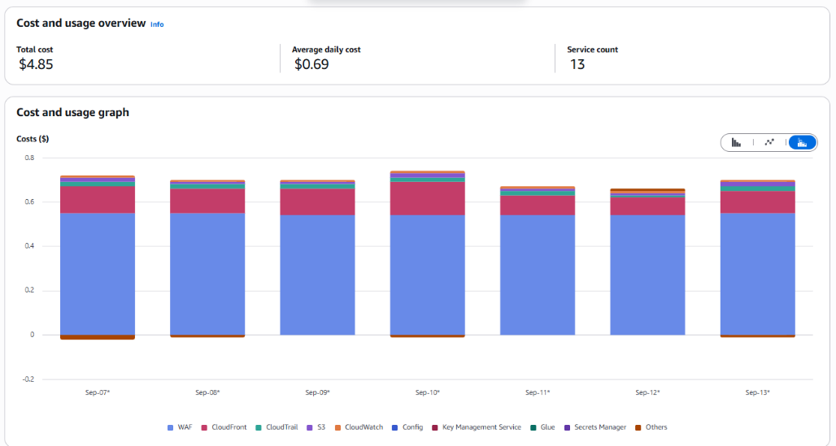
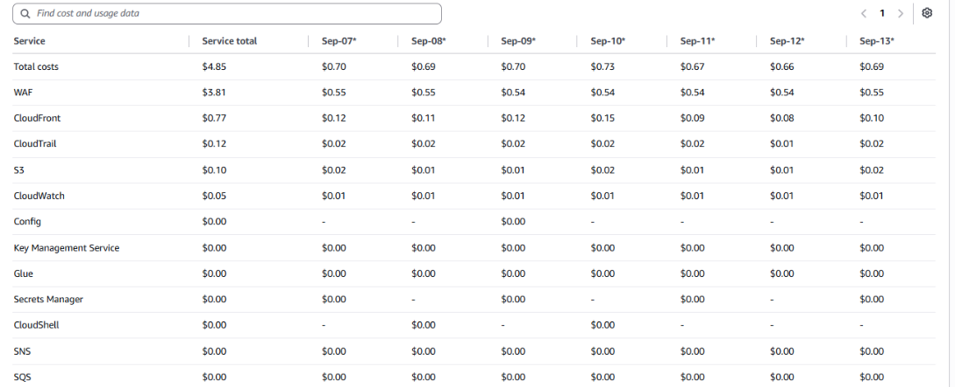

- The cost remains same.

- No Resource Utilization & Alarms

- No Activity performed by Operisoft in this account.

---------------------------------------------------------------------------------------------------------Summary----------
Aptech AI_Applications-166185345052
-----------------------------------------------------------------------------------------------------------------------------

Billing and Cost Overview

  - Total cost for the week: $18.74
  - Average Daily Cost: $2.68

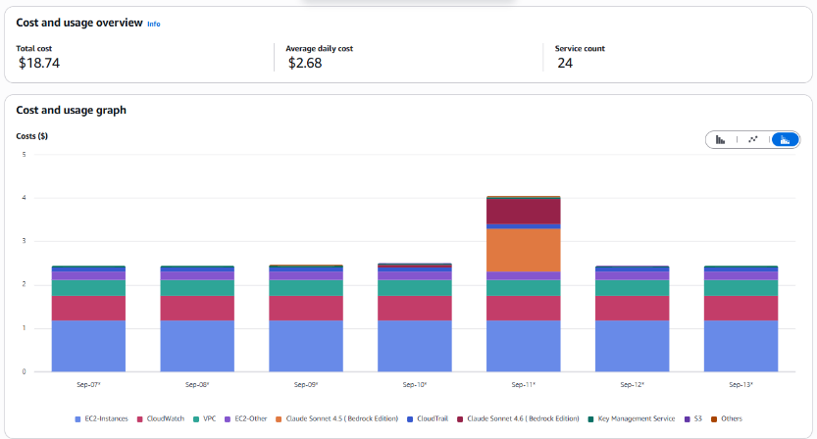

.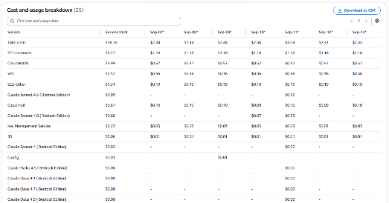

- The cost slightly increased compared to the previous week due to usage of services: Bedrock.
- No Activities performed by Operisoft in this account.
- No Resource Utilization & Alarms
---------------------------------------------------------------------------------------------------------Summary----------

Aptrack AR_VR_MAAC - 377555974222
------------------------------------------------------------------------------------------------------------------------------

Billing and Cost Overview

  - Total cost for the week: $41.64
  - Average Daily Cost: $5.95

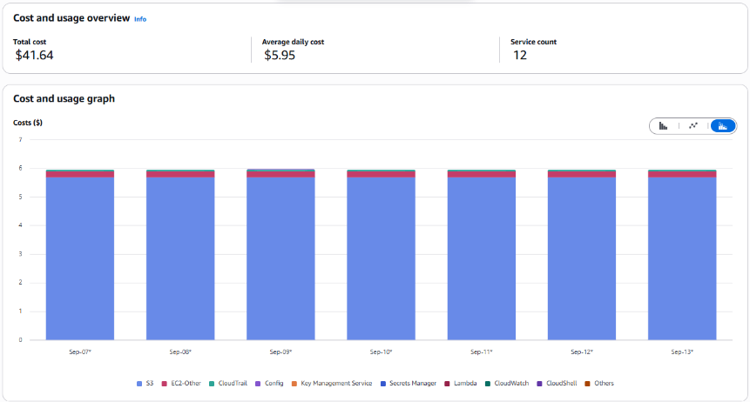

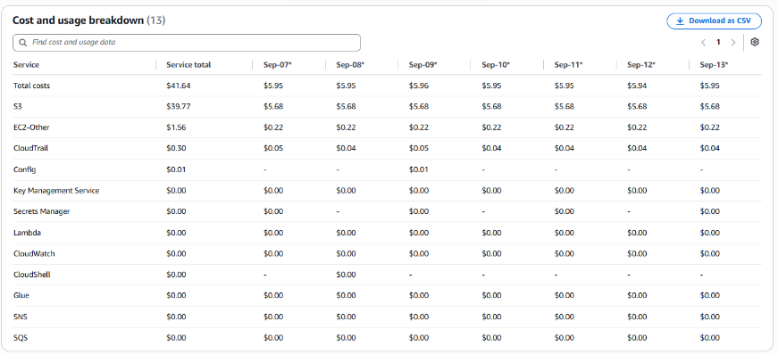

- The cost remains same.
- No Resource Utilization & Alarms.

- No Activity performed by Operisoft in this account.

---------------------------------------------------------------------------------------------------------Summary------

Aptrack - 2.0 - Log archive [MEL] - 637423329781
--------------------------------------------------------------------------------------------------------------------------

Billing and Cost Overview

  - Total cost for the week: $2.68
  - Average Daily Cost: $0.38

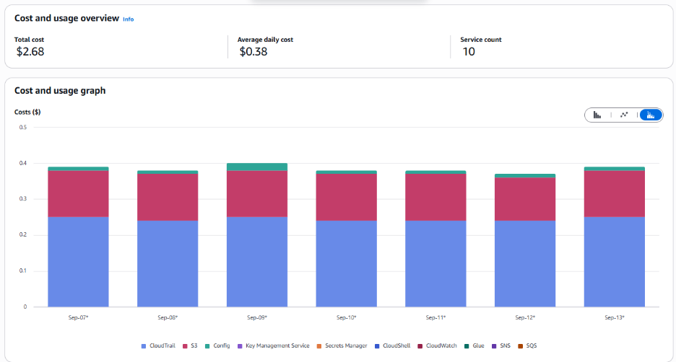

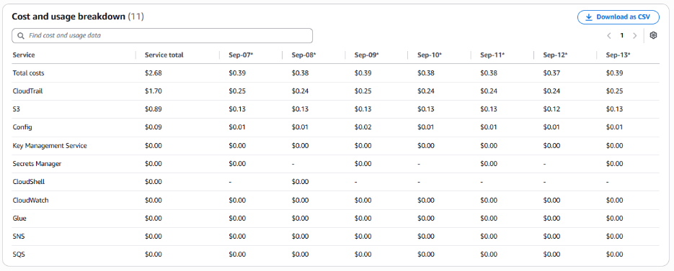

- The cost remains same.

- No Activity performed by Operisoft in this account.
- No Resource Utilization & Alarms.

-----------------------------------------------------------------------------------------------Summary-----------

Aptech_Domains - 622050225451
-------------------------------------------------------------------------------------------------------------------

Billing and Cost Overview

  - Total cost for the week: $1.84
  - Average Daily Cost: $0.26

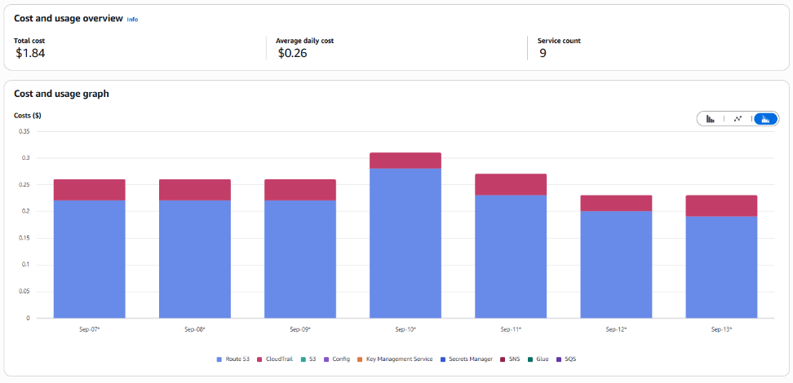

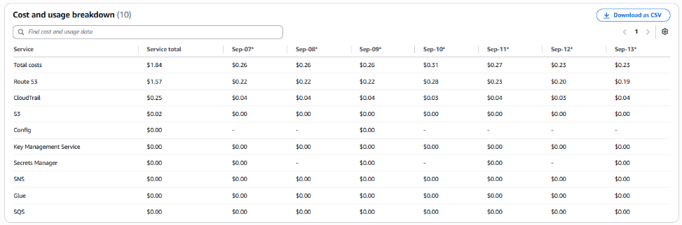

- The costs have decreased compared to the previous week due to the usage of services such as Route53(HostedZone).

- No Activity performed by Operisoft in this account.

- No Resource Utilization & Alarms.

-----------------------------------------------------------------------------------------------------Summary------

Aptrack - 2.0 - Audit [MEL] - 851725245759
---------------------------------------------------------------------------------------------------------------------

Billing and Cost Overview

  - Total cost for the week: $0.36
  - Average Daily Cost: $0.05

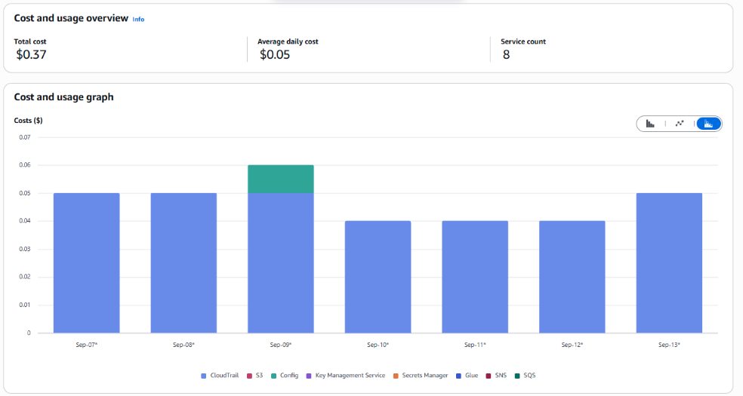

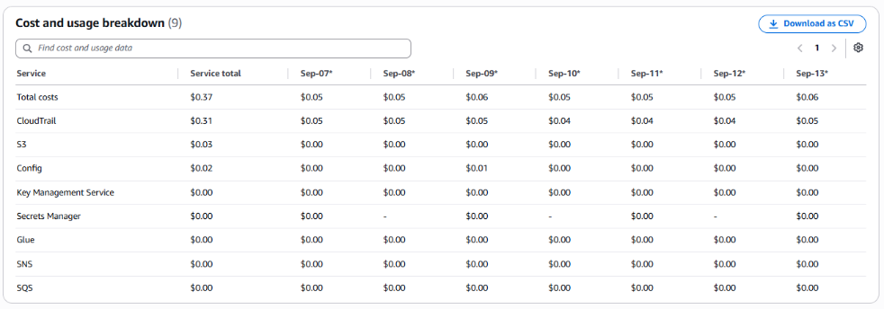

- The costs remain same.

- No Resource Utilization & Alarms.

- No Activity performed by Operisoft in this account.

------------------------------------------------------------------------------------------------------------Summary----

Aptech - International - 470684059456
--------------------------------------------------------------------------------------------------------------------------

Billing and Cost Overview

  - Total cost for the week: $17.89
  - Average Daily Cost: $2.56

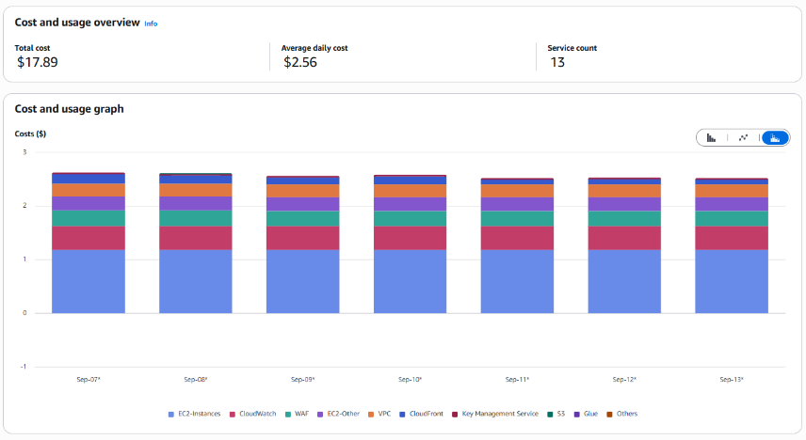
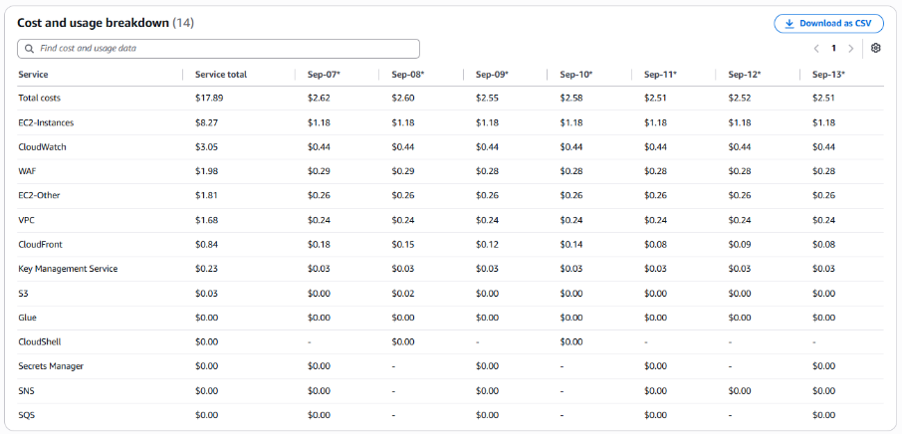

- The cost remains same
- No Activity performed by Operisoft in this account.
- Resource Utilization & Alarms.
All EC2 Server Alarms triggered between (14 September 2026 to 20 September 2026)
Server Name | Region | Memory/Disk/CPU | Alert date and no. of trigger
aptech-internation  (i-0e91459b67972c9fd) | ap-south-1 | CPU 80% | September 18(1 Time)
aptech-internation  (i-0e91459b67972c9fd) | ap-south-1 | Disk 90% [/] | September 17(1 Time)
aptech-internation  (i-0e91459b67972c9fd) | ap-south-1 | Disk 80% [/] | September 17(1 Time)

-- End Of Document --

